|  |  |
| --- | --- |
| ANNEXURE No. | (To be added by PSLV) |
| PAYLOAD | BGS ARPIT (**A**mateur **R**adio **P**ayload for **I**nformation **T**ransmission) |
| AGENCY | SJC Institute of Technology, Chickballpur |

|  |  |
| --- | --- |
| Prepared by | Prof. Shreehari H S, Assistant Professor, SJCIT |
| Reviewed by | **Mr. B A Subramani, Rtd Space Environmental Simulation Engineer, U R Rao Satellite Centre, Bengaluru** |
| Approved by | **Dr. G T Raju, Principal, SJCIT** |

Contents

2 Applicable documents 3

3 Payload Mission Objective 3

4 Payload Mechanical Configuration 4

5 Payload Electrical Configuration 13

5.1 Payload power configuration 18

Electrical Interfaces 19

5.2 Payload data configuration 21

5.3 Payload RF configuration 21

6 Payload Tele-Command Configuration 22

7 Payload Thermal properties 23

8 Payload operation sequence 24

9 Payload requirements at SDSC 24

10 Payload mass simulator 24

|  |  |  |  |
| --- | --- | --- | --- |
| **Revised Version** | **Release Date** | **Change Record** | **Effective Pages** |
| 1.0 | 12-02-2024 | Proposal Submission | 19 |
| 2.0 | 21-02-2024 | Changes in the sequence of events, added captions to figures, Antenna Specifications with diagram attached | 20 |
| 3.0 | 28-03-2024 | All changes and additions as suggested by PSLV team, signed CAD drawings of package and antenna | 24 |
| 4.0 | 30-03-2024 | Mass properties, Solar absorptivity and IR emissivity values added, Top view of the CAD model updated with Origin and Centre of Mass indication, updated mass of the package, References added. | 24 |
| 5.0 | 02-04-2024 | Typos corrected for frequencies and their applications in page 21 | 24 |

# Applicable documents

# Payload Mission Objective

The proposed payload for PSLV stage 4 (POEM) is being developed jointly by SJC Institute of Technology, UPARC (Upagrah Amateur Radio Club), and AMSAT-INDIA. The primary objective of the payload is to provide new avenues for amateur radio satellite service in India and across the globe. This payload can also be used as an educational outreach tool providing services towards student fraternity and start-ups among the reforming Indian space sector and also to celebrate and commemorate India’s 75th Independence Year – Azadi Ka Amrit Mahotsav.

**Objectives**

To design, develop and launch a payload to perform the following functions:

* 1. Pre-Recorded image transmission using Slow Scan Tele-Vision (SSTV) E.g., Pictures depicting important milestones/achievements of India’s contribution in the field of Space Science and Amateur Radio.
  2. Pre-Recorded Audio message transmission E.g., Preamble of Indian Constitution.
  3. Telemetry (House Keeping/ Health Parameters) transmission (AX.25 packet) with APRS digipeater capability. E.g., Health parameters of the payload, useful for amateur and start-up fraternity to understand the in-orbit performance of the payload
  4. Morse Code (CW) Beacon E.g., Identification of payload with brief telemetry.
  5. Acknowledgment (QSL card) for successful user uplink E.g., Real-time acknowledgment in a broadcast mode of the contact with the payload from the user in image or text format.
  6. Telecommand-based mode selection for primary functions 1,2 & 5

**General System Requirements**

1. The system includes the necessary electrical and mechanical interfaces with respect to the Launch Vehicle specifications.
2. The payload should be securely connected with the launch vehicle, and is required to receive a continuous power supply within the range of 24V-42V(raw) throughout the entire duration of journey.
3. The payload does not need telemetry and telecommand (TM and TC) requirements from the launch vehicle. Therefore, no communication is required from the platform, except for power supply.
4. The payload does not have provision for ON/OFF. We expect control from POEM platform.

# Payload Mechanical Configuration

Add payload size, interface with PSLV, volume of the payload, mass properties of the payload, signed drawing of interfaces with PSLV, requirement of mounting direction, connector location drawing, connector locking mechanism.

Immediately after realisation of FM, the measured mass property note shall be provided and this document to be updated giving comparison of estimate vs realised properties.

|  |  |  |  |
| --- | --- | --- | --- |
| **ID** | **Parameter** | **Unit** | **Specification** |
|  | Mass of the payload(Approx)  (Excluding Antenna) | g | 350 |
|  | Payload Volume (Excluding Antenna) | mm 3 | 165x136x25 |
|  | Mass of the antenna (Approx) (Inverted F antenna) [Will be mounted on the deck of POEM] | g | 350 |
|  | Antenna Volume | mm 3 | 500×40×114 |
|  | Power requirement from PS4-OP | - | **Peak** (Tx mode): 7 W  **Standby** (Rx mode): 0.5 W |
|  | Payload mechanical interface | - | 4 x M4 screws |
|  | Requirement of mounting direction | - | Preferably towards earth viewing side |

CAD DRAWING OF THE PACKAGE:

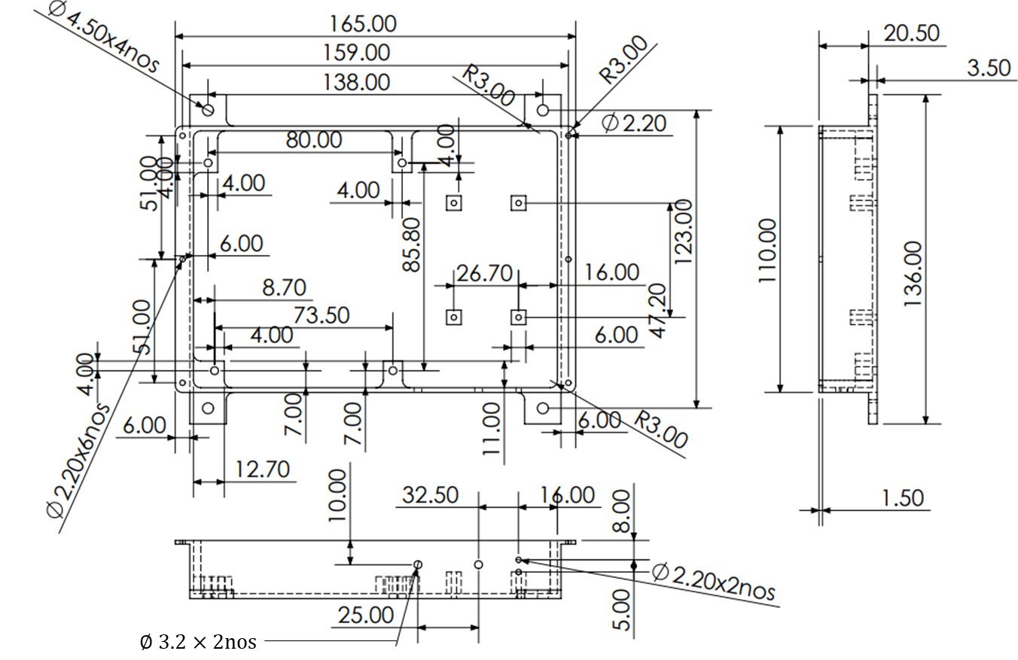

Figure: 2D CAD Model

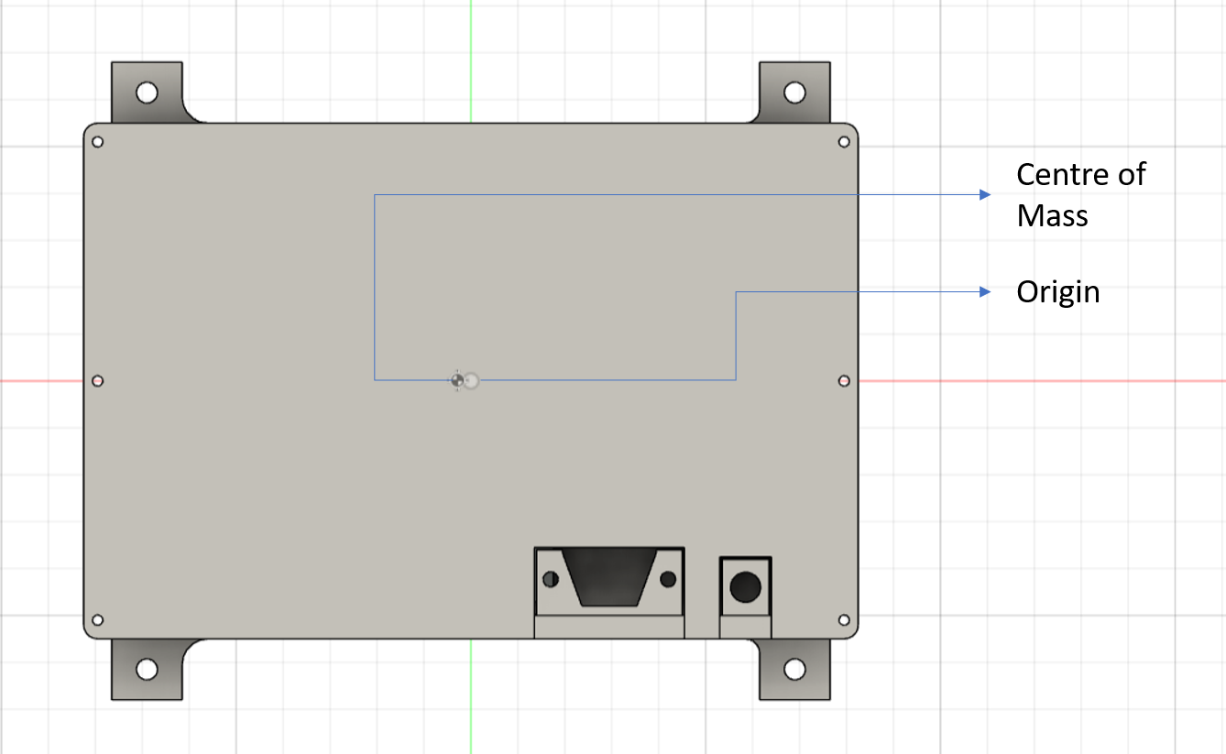

Figure: Top view of 3D CAD Model

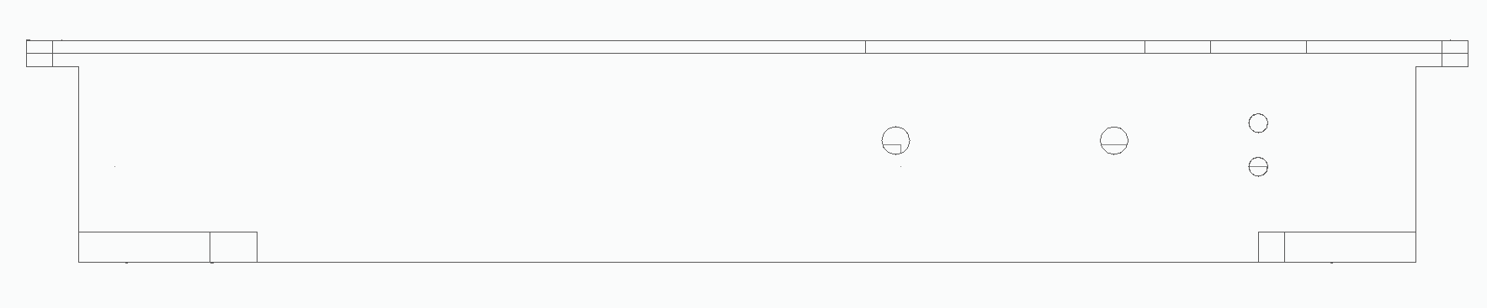

Figure: Front View of 3D CAD Model

Connector Brackets Used:

1. RF Connector Bracket:

Material Used: Aluminium 6061

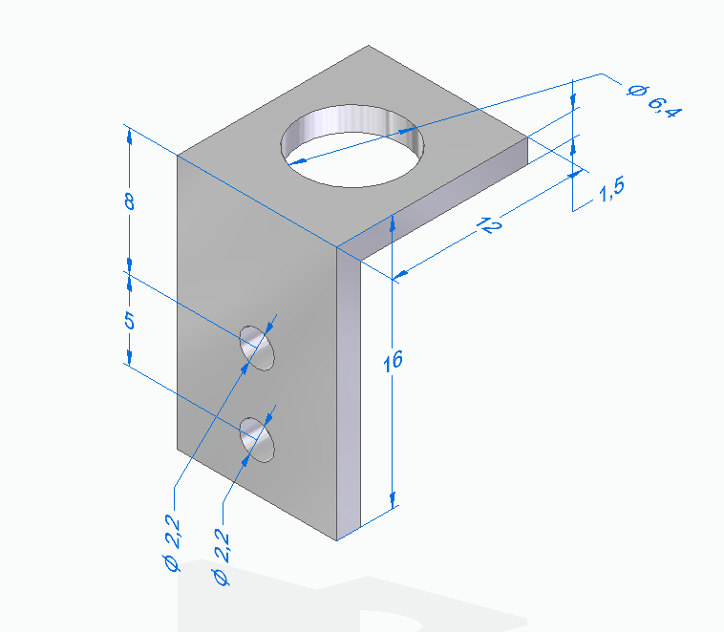

1. DB9 Connector Bracket:

Material Used: Aluminium 6061

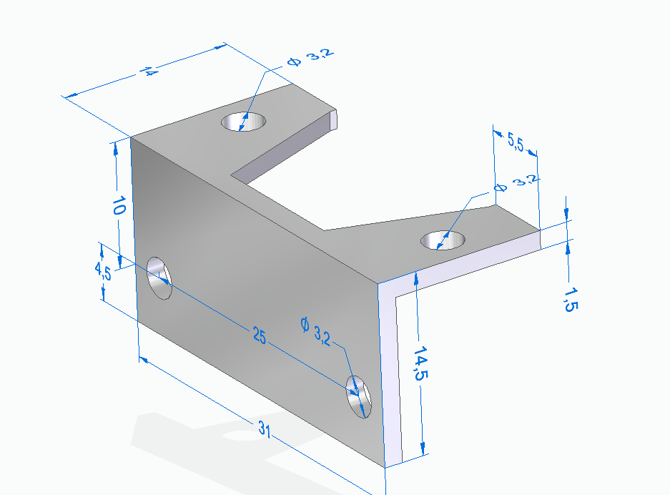

Antenna Specifications with CAD drawings:

**Inverted F Antenna For BGS ARPIT**

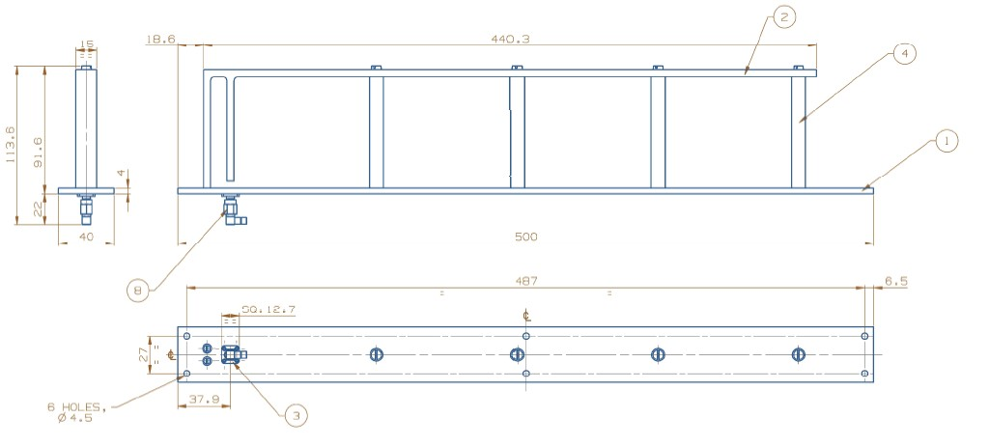

|  |  |  |  |
| --- | --- | --- | --- |
| SL.NO. | DESCRIPTION | QTY. | MATERIAL |
| 1 | BASE | 1 | AL-6061 |
| 2 | ANTENNA | 1 | AL-6061 |
| 3 | SMA Connector | 1 | STD |
| 4 | SPACER | 4 | DELRIN |
| 5 | Cheese_Head_Screw_M4*8 | 4 | STD |
| 6 | Slot_CS_Head_Screw_M4*8 | 4 | STD |
| 7 | Slot_CS_Head_Screw_M3*6 | 2 | STD |
| 8 | SMA Socket L | 1 | STD |

**Testing Method for Antenna:** Antenna would be mounted on a plate and all the environmental tests would be carried out.

Radiation Pattern:

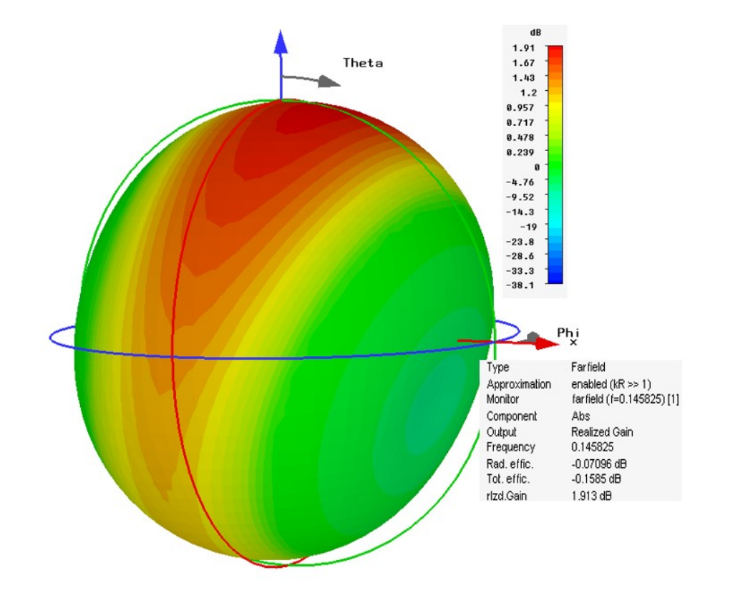

Antenna Gain Plot:

Antenna Gain: Maximum +2 dB and minimum - 8 dB

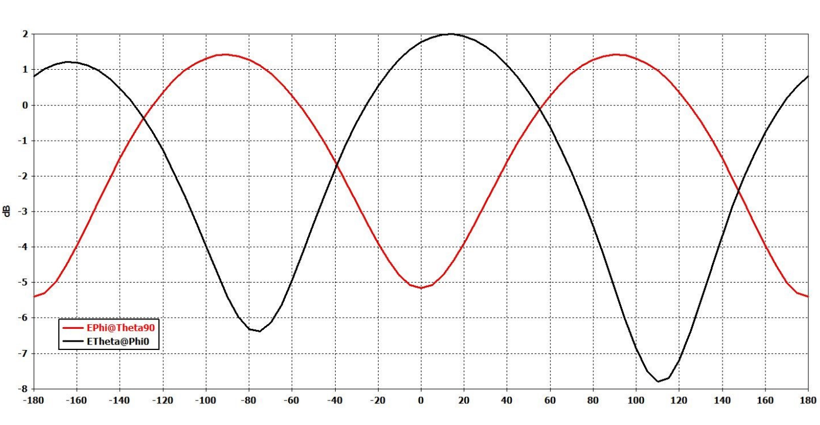

**Mass Properties:**

|  |  |  |
| --- | --- | --- |
| **Parameter** | | **Value** |
| Mass (g)(Approx.) | | 350 |
| Centre of Mass (𝑚𝑚) | 𝑋 (𝑚𝑚) | -2.715 |
| 𝑌 (𝑚𝑚) | 0.006 |
| 𝑍 (𝑚𝑚) | 12.464 |
| Moment of Inertia (At Centre of Mass)  2  (𝑔 𝑚𝑚 ) | 𝐼𝑥𝑥 |  |
| 𝐼𝑦𝑦 |  |
| 𝐼𝑧𝑧 |  |
| Moment of Inertia (At Origin)  2  (𝑔 𝑚𝑚 ) | 𝐼𝑥𝑥 |  |
| 𝐼𝑦𝑦 |  |
| 𝐼𝑧𝑧 |  |

# Payload Electrical Configuration

|  |  |  |  |
| --- | --- | --- | --- |
| **Electrical** | | | |
| **ID** | **Parameter** | **Unit** | **Specification** |
| 1. | Payload electrical interface | - | **On Payload:**  **Part Number:** IM24308/3-1F-ND  **Manufacturer:**  ITT Cannon, LLC  **Description**:**9 Position D-Sub Plug, Male Pins Connector**  **From Platform:**  The expected connection is a female DB9 D-sub connector (9 Pin) |
| 2. | Power requirement from PS4-OP | - | **Peak** (Tx mode): 7 W  **Standby** (Rx mode): 0.5 W |

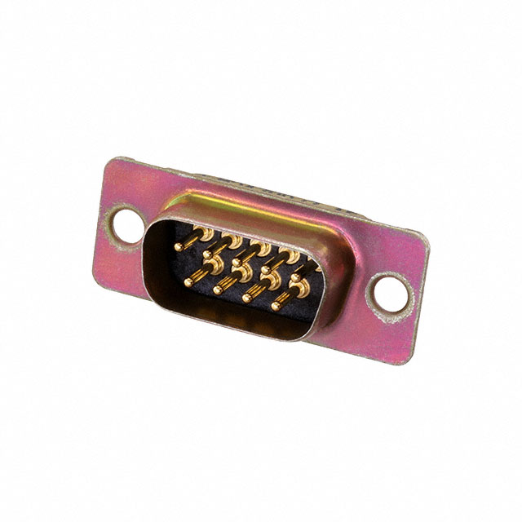

Figure: DB9 IM24308/3-1F-ND

**Circuit Schematic**

The circuit schematic of the payload is shown in figures 5.1 to 5.6.

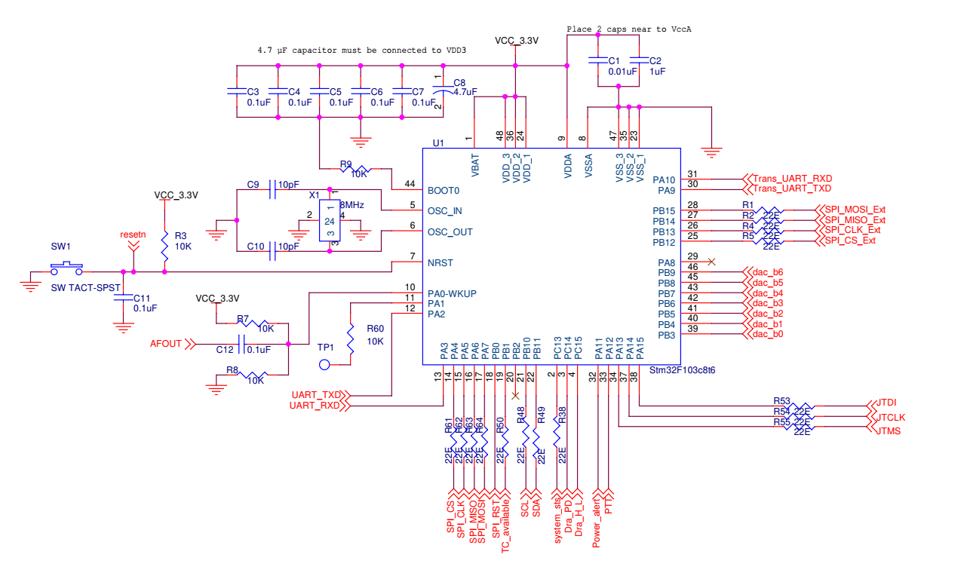

Figure 5.1: Baseband processor of the payload using STM32F103CBT6

The task of the baseband processor is to interface with memory, RF transceiver and power sensor to initialize the whole payload and perform the baseband data handling operations. STM32F103CBT6 microcontroller is clocked using 8 MHz crystal oscillator which is further multiplied by 9 internally to generate 72 MHz system clock. It also interfaces with R-2R DAC via parallel port. Figure 5.1 shows the schematic of the configuration of microcontroller as a baseband processor.

Raw bus supply of 28V-42V is first down converted to 12V using isolated DC-DC converter. Furthermore, 12V is down converted to 3.3V and 4V using LMZ14202 and details are as shown in the below figures.

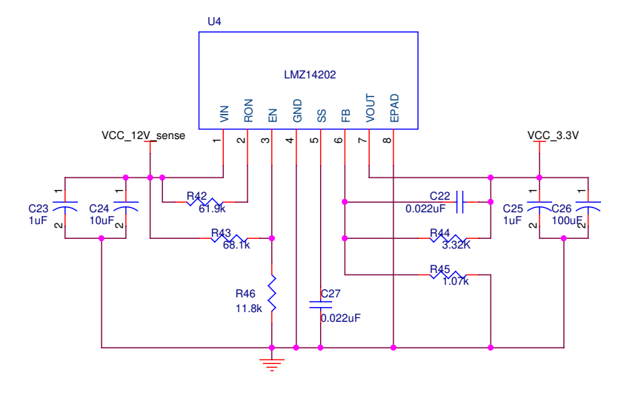

Figure 5.2: DC-DC stepdown converter for microcontroller power supply

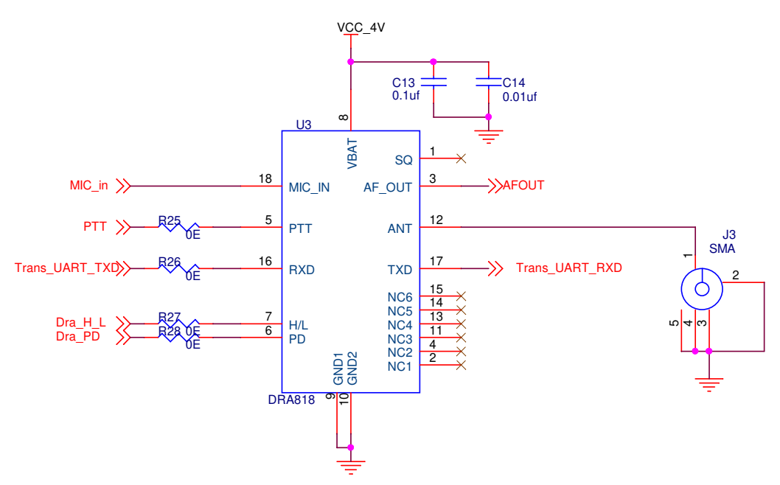

Figure 5.3: Configuration of RF transceiver

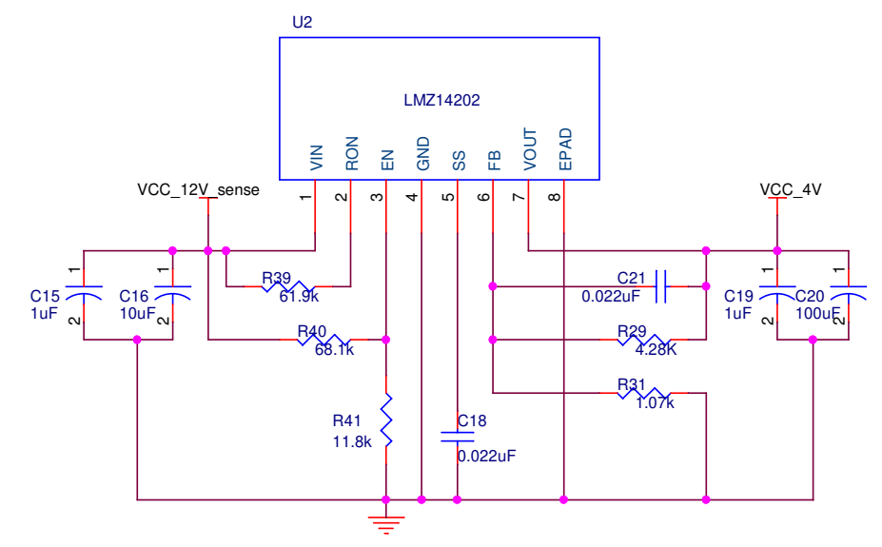

Figure 5.4: DC-DC stepdown converter for RF Transceiver power supply

RF front end of the payload is being handled by FM transceiver (SA868v) to receive APRS packets and transmit the baseband modulated audio signals. The FM transceiver, SA868v, operates on frequency range from 134 MHz to 174 MHz. It can be configured for a single channel of either 12.5 KHz or 25 KHz with maximum frequency deviation of 2.5 KHz. The FM transceiver needs to be configured over UART interface and the output power can be controlled using level command either in High (2 W) or Low (0.25 W) mode. The transceiver can be kept in sleep mode by providing a level command. These functionalities are implemented by microcontroller. Interface between FM transceiver and antenna is provided via SMA connector. Figure 5.3 shows the schematic of the FM transceiver configuration. The power supply schematic to generated 4 V supply from satellite raw supply is shown in figure 5.4.

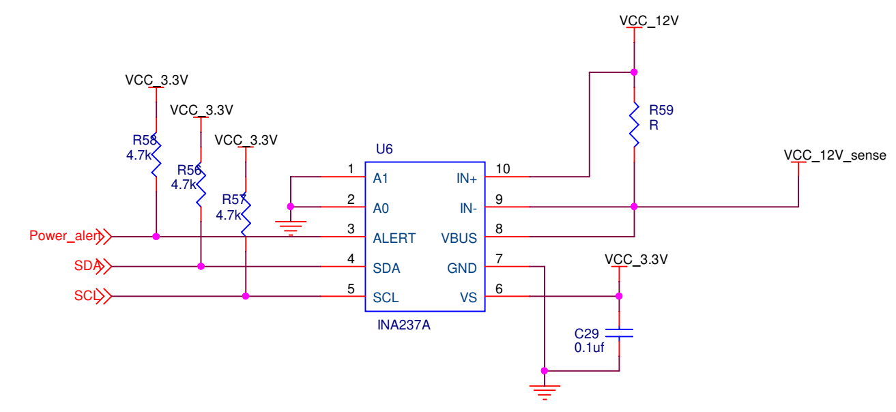

Figure 5.5: Power sense module

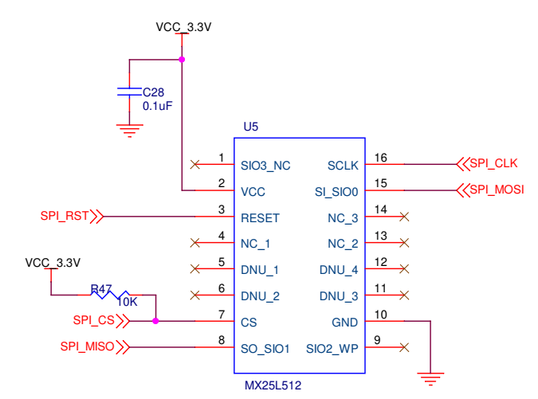

Figure 5.6: Flash Memory module

Memory and power sensor module shown in the figure 5.5 and 5.6 are used to store the message and to sense the status of power supply respectively. Power sense module is interfaced with microcontroller via I2C interface whereas memory module is interfaces with microcontroller over SPI protocol. It is to be noted that the flash memory will be programmed to store the data before the T&E of the payload and shall not be written subsequently.

Arrangement is provided as an indicator for secondary supply status via separate LEDs on the card. These LEDs can be made during the final T&E of the payload and in the flight model of the payload.

## Payload power configuration

Add payload powering schematic, connector designation, part no. and manufacturer, Pin identification in drawing, pin definition in a table giving requirements, table of power consumed during payload operation

**Payload Powering Schematic:**

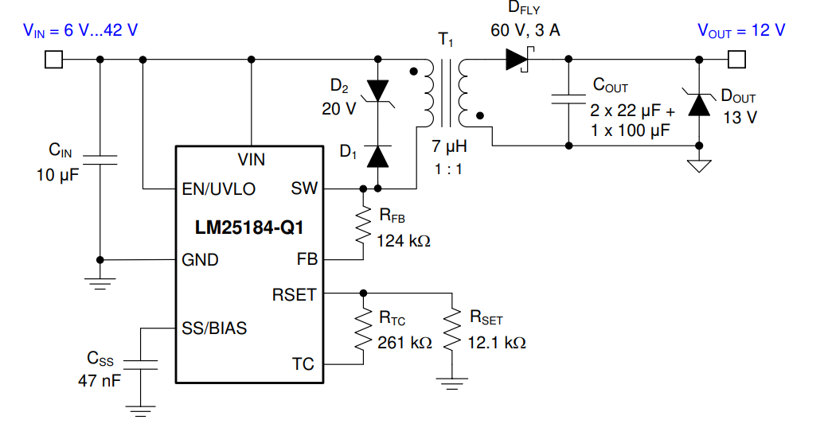

Vin 🡪 PIN 1

GND 🡪PIN 5 of DB 9 connector

**Pin Definition of DB9 Interface Connector:**

|  |  |
| --- | --- |
| Pin 1 | RBLIVE |
| Pin 2 | NC |
| Pin 3 | NC |
| Pin 4 | NC |
| Pin 5 | RBRETURN |
| Pin 6 | NC |
| Pin 7 | NC |
| Pin 8 | NC |
| Pin 9 | SGRP |

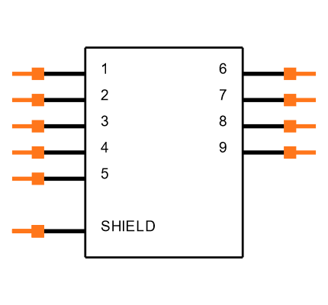

# Electrical Interfaces

Multimode message transmitter payload shares electrical interface with POWER and OBC of the PS4 stage of the PSLV.

**Interface with Power**

The payload interfaces with power subsystem to receive raw bus supply. Secondary voltage levels of 3.3V and 4V required for microcontroller and RF transceiver are further derived from raw bus via DC-DC converters and switching step-down regulators. Figure 5.7 shows the power interface scheme of the payload.



Figure 5.7: Interface with Power

**Interface with OBC:** The payload interfaces with OBC to receive ON/OFF command. Figure 5.8 shows the interface details between OBC and payload.



Figure 5.8: Interface with OBC of PSLV

## Payload data configuration

Add payload data connector designation, part no. and manufacturer, Pin identification in drawing, pin definition in a table giving requirements, data volume to be generated per orbit, RS485 interface definition.

Details of magnet if any on the payload to be added.

**No payload data exchange with PSLV**

## Payload RF configuration

Applicable to RF payloads. Provide the centre frequency of transmitter and receiver and their bandwidth, power of transmission.

**145.825 MHz – APRS (Digipeater, Telemetry Packet)**

**145.870 MHz– Other modes (Voice, SSTV)**

| **Parameters** | | **Units** | **Values** |
| --- | --- | --- | --- |
| Parameters to be measured | | - | NA (Power (28V to 42V) with ON/OFF capability with ON/OFF status TM)  TM/TC and other parameters are communicated with the payload using APRS packets over payload frequencies)  **Data Rate: 1200 bps** |
| TM/TC | | - |
| Data Rates | | - |
| Frequency of operation | | MHz | 145.825 (Digipeater Operation)  145.870 (Tentative, subject to EMI requirements of POEM) |
| Baud Rate | |  | 1200 |
| Duty Cycle | |  | 67% |
| Transmit power | | W | 2 |
| FM Frequency deviation | | Hz | 2500 |
| RF Modulation | |  | FM |
| Message types | |  | Audio, Text, Image |
| Baseband Modulation | Audio |  | None, sampled and quantized audio |
| Text |  | AFSK modulation, AX.25 Frame Format |
| Image |  | SSTV PD120 and Robot72 Modes |

**Standard Packet structure of Beacon:**

AX.25 frame format:

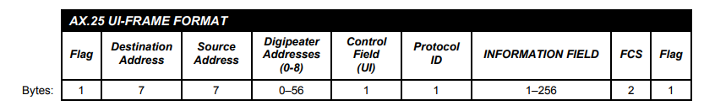

Figure: AX.25 Frame Format

Source: APRS PROTOCOL REFERENCE Protocol Version 1.0

# Payload Tele-Command Configuration

Add table of telecommands to be generated to be uploaded during on-orbit operations.

|  |  |  |
| --- | --- | --- |
| **Sr.**  **No.** | **Commands** | **Description** |
| 1. | ARPIT PAYLOAD ON | This command is for switching ON the payload. Shall be given to PSLV relay package. |
| 2. | ARPIT PAYLOAD OFF | This command is for switching OFF the payload. Shall be given to PSLV relay package. |

The switching of mode selection (from Voice to SSTV to Digipeating) is done through autonomous operation.

# Payload Thermal properties

The thermal properties of the payload materials to be provided. (IR Emissivity, Solar Absorptivity, surface finish)

**Surface Finish - 3.2 microns**

**Mounting Flange Material - Aluminium 6061.**

|  |  |  |  |
| --- | --- | --- | --- |
| Sl. No | Material | Solar Absorptivity | IR Emissivity |
| **1** | **Aluminium 6061** | **0.14 [1]** | **0.84 [1]** |
| **2** | **FR4** | **0.8-0.95 [2]** | **0.8 [2]** |

[1] <https://www.redrok.com/concept.htm#emissivity>

[2]<http://mstl.atl.calpoly.edu/~workshop/archive/2011/Spring/Posters/poster_jaegun_trio_cinema.pdf>

**Operational Temperature Limits: -25 to +85** (The temperature limits for each component used is attached in the excel sheet)

**TML Values:**

|  |  |  |
| --- | --- | --- |
| Sl. No | Material | TML Value |
| 1 | FR4 of the PCB | 0.35% |
| 2 | Aluminium of the housing and antenna | 0.12% |
| 3 | PEEK of isolation plate | 0.14% |

(All values are obtained from NASA Outgassing Database)

# Payload operation sequence

Add the sequence of activity of the payload from the time it is commanded to ON condition.

**Sequence: (As the payload is designed for Amateur Radio Service, requesting PSLV to keep it ON till end of mission).**

|  |  |  |  |
| --- | --- | --- | --- |
| **Sl. No** | **Sequence of Activity** | **Time in seconds** | **Power (W)** |
| 1 | Power ON | T0 |  |
| 2 | Audio Transmission | T1 = T0 + 30 | 7 |
| 3 | Silence | T2 = T1+ 60 (Digipeating) | 0.5 |
| 4 | Image Transmission (Total 30 images)  (Image Tx through PD -120 SSTV mode)  **Plan is to receive 2 images in one pass** | T3 = T2 + (126 per image)  +  **Silence**: T4 = T3 + 60 (Digipeating)  T5 = T4 + (126 per image)  +  **Silence**: T6 = T5 + 60 (Digipeating) | 7  0.5  7  0.5 |
| 5 | **TOTAL** | **T = 462** |  |

# Payload requirements at SDSC

**DC test required.**

# Payload mass simulator

The configuration of the mass simulator that will be launched, in case of delay in payload readiness is to be added. The interface shall be identical to the detail in Section 4.

**Will be provided, if required.**